Armed Forces stakeholder brief
February 2023

Welcome to the first Armed Forces stakeholder brief of 2023 and a belated happy new year to you all; thank you to everyone for your hard work across Armed Forces health in 2022.
The pace of work in Armed Forces health has continued into 2023 and we are pleased to be able to share the details of two successful procurements; Op COURAGE, the Veterans Mental Health and Wellbeing Service and a new service for veterans in the criminal justice system.
This year is a particularly poignant one, as 5 July 2023 marks the 75th year of the NHS. Millions of people in the UK have received treatment and assistance from the NHS since it was created in 1948, and it continues to be a beloved institution we are glad to have. We honour the devotion and work of our NHS colleagues who have never faltered in their effort to providing the finest care possible.
In support of this poignant day, The Royal Mint has launched a specially designed 50p coin to mark the 75th anniversary of the NHS. The coin, part of a commemorative collection, will raise money for NHS Charities Together which helps the NHS go further for staff and patients.

Op COURAGE update

With NHS veterans mental health services continuing to expand and improve over recent years, nearly 30,000 veterans have benefitted from this dedicated care and support since 2017. Part of this success has been the development of the name, Op COURAGE: The Veterans Mental Health and Wellbeing Service, which veterans and their families created to help improve awareness of and confidence in this service.

Op COURAGE is the overarching name for the following three veterans mental health services:

- Veterans' Mental Health Transition, Intervention and Liaison Service (TILS)
- Veterans' Mental Health Complex Treatment Service (CTS)
- Veterans' Mental Health High Intensity Service (HIS)

As part of NHS England’s ongoing commitment to improving veterans mental health services, the TILS, CTS and HIS are being brought together under an Op COURAGE service specification. This means that from 1 April 2023, each regional Op COURAGE service has one lead provider (see table below). Each lead provider will work in partnership with a range of organisations, including charities, to offer a holistic range of mental health care and treatment that is tailored for those accessing the service.

Lead provider | Region
North Tyne & West NHS Foundation Trust | North of England
Essex Partnership University NHS Foundation Trust | East of England
Lincolnshire Partnership NHS Trust | Midlands
Berkshire Healthcare NHS Foundation Trust | South East England
Camden & Islington NHS Foundation Trust | London
Avon and Wiltshire Partnership NHS Foundation Trust | South West England

In addition, we are currently working on a campaign to raise awareness of Op COURAGE and encourage veterans struggling with their mental health to seek help from this service. Thank you to everyone who is supporting the development of this campaign. We look forward to sharing further details over the coming months.

Improving care and support for veterans in the criminal justice system
‘Healthcare for the Armed Forces community: a forward view’, sets out nine commitments to improve care and support for individuals during, leaving and after military Service. Commitment six focuses on ‘supporting veterans in the criminal justice system’, which includes developing a service model that meets the needs of veterans pre, during and post prison custody. To help inform this work, NHS England undertook a programme of engagement last summer on a proposed service model to support these individuals. The proposed model of care set out intentions for a non-clinical service pre and post prison custody and a prison officer and healthcare staff training package during prison custody. Views were captured from veterans and their families with lived experience of the criminal justice system, as well as from individuals working in this area.
Findings from the engagement have informed the specification for this new service, which focuses on pre and post prison custody support and launches on 1 April 2023 launch. Due to the engagement highlighting that in prison custody support for veterans required more than a training and education package, further evidence and information is being sought to inform appropriate arrangements within this setting for commissioning at a later point in time.
Please see attached for a copy of the engagement report, which highlights the importance of an appropriate name for this service. We are therefore holding a series of focus groups over the forthcoming weeks to seek views on what this should be. Those interested in attending a focus group or sharing their views via a survey should please register here or email kate.barnett12@nhs.net for more information.

Veterans Trauma Network conference
The Veterans Trauma Network (VTN) held its annual conference on Wednesday 11 January, in London. Following on from the VTN’s success at the HSJ Awards, Minister for Veterans’ Affairs, Johnny Mercer addressed the conference, highlighting the need for a single veteran physical care pathway across the NHS. The minister also paid tribute to Kate Davies, our National Director for Health and Justice, Sexual Assault Services and Armed Forces for her relentless commitment to veteran healthcare.
The minister’s full speech can be found on the gov.uk website.
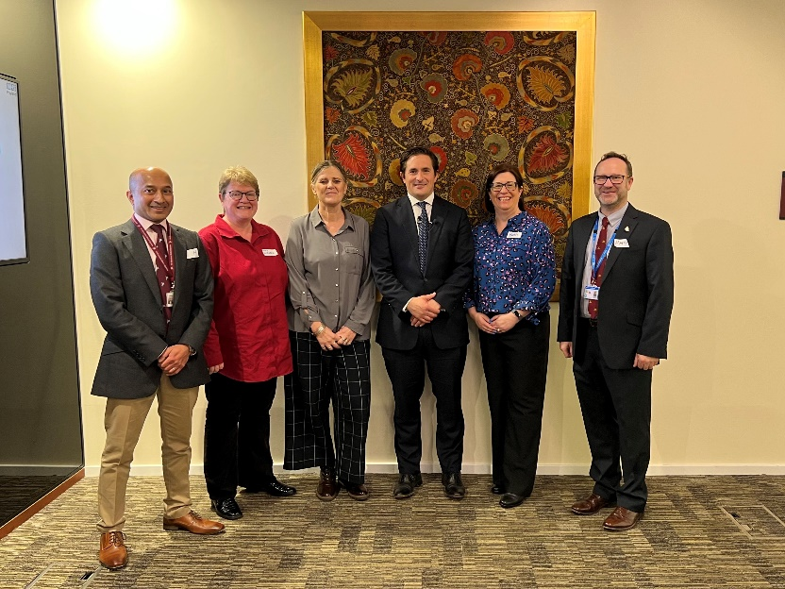
Mr Mercer’s speech followed that of Kate Davies, who set the context for veteran healthcare in England and the shared responsibility NHS England has with integrated care boards (ICBs), along with the launch of the statutory due regard to the Armed Forces Covenant. The importance of parity for both mental and physical health care for veterans was discussed, with attendees also hearing from the devolved nations about the work they are doing to support veteran healthcare across the United Kingdom.
The VTN is managed by surgeon and reservist Mr Shehan Hettiaratchy and National Service Manager Beth Lambert. In November 2022, the VTN won the HSJ Award for civilian and military partnership. Rather than giving priority access to NHS care, the VTN works in partnership with military charities to ensure veteran patients ‘wait well’ and to ensure their wider health needs are supported.
Veterans can be of any age and only need to have served one day in the British Armed Forces. Veterans with service attributable physical health needs can be referred to the VTN by their GP.
There are currently an estimated 1.8 million veterans in the UK, according to recent census data. To find out more about the VTN, visit the Veterans, service leavers, and non-mobilised reservists page of the NHS website.
Military maternity project in Lincolnshire
Our national director Kate Davies, CBE and colleagues from the Armed Forces team at NHS England recently attended a special presentation by Lincolnshire ICB on the work they have been doing to support the military community access maternity services. This included a presentation given by the Better Births programme in Lincolnshire, where they have been piloting a dedicated maternity service for the Armed Forces community.
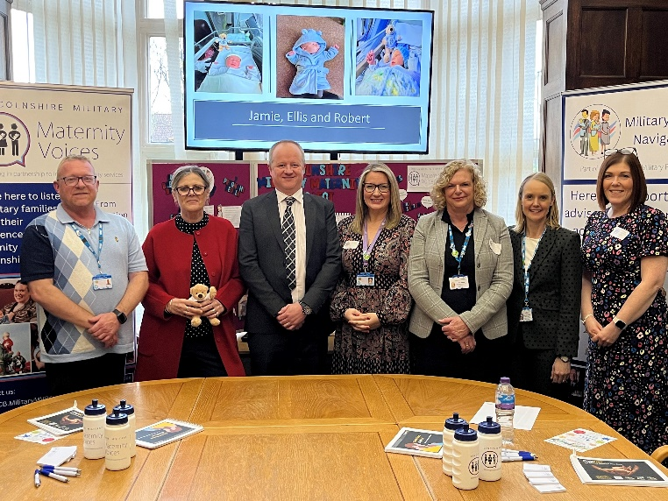
Maternity Voices Partnerships, commonly known as MVPs, first began to appear in 2018 as part of the maternity transformation programme. MVPs bring together stakeholders across maternity services at a local level, which includes midwives, parents, service user representatives, commissioners, health visitors and third sector organisations.

MVPs facilitate the coproduction of maternity services so that they represent the needs of the local community. It is a core aim of MVPs that they amplify the voices of those who are seldom heard.

In Lincolnshire, MVP Chair Amanda Pike noticed recurrent themes in the feedback she was receiving from military families. For example, many families were experiencing difficulties in accessing maternity care as they moved in and out of Lincolnshire on military postings. Working with the Local Maternity and Neonatal System (LMNS) and ICB colleagues, Amanda was introduced to the Armed Forces commissioning team at NHS England.

NHS England colleagues have subsequently worked with Lincolnshire LMNS and MVP to pilot a dedicated military maternity project. This has involved recruiting a dedicated Military MVP Lead, Susie Dachtler, and Military Care Navigator, Dave James.

Together Susie and Dave ensure the voices of military families are heard and that they receive the right care and support they need. Dave, himself an ex-RAF Warrant Officer, has been able to support military families navigating fertility, maternity and early years services. One service user said:

“I have been so impressed with all the contact
I have had with the military care navigator
and I believe that this role will help many people
particularly those who have to move whilst pregnant
for military postings”

You can find out more in this video.

NHS Talking Therapies for Anxiety and Depression – the new name for IAPT services
Improving Access to Psychological Therapy (IAPT) services have been renamed as ‘NHS Talking Therapies for Anxiety and Depression’. This work has taken place after understanding the previous name had become a barrier to access. A stakeholder survey was shared at the end of 2022 seeking new name options, looking particularly at the service name and tagline. The outcome of this survey has informed the new name, NHS Talking Therapies for Anxiety and Depression, which reflects the nature of the service better.
IAPT services were launched in 2008 with a promise to provide effective psychological therapies to far more people experiencing the most common mental health problems: anxiety and depression.
The services have been successful, with 6.5 million people receiving a course of treatment and around 50% fully recovering. The services aim to be flexible, with patients often offered a choice between different effective treatments and how the treatments are delivered. It has been advised that the name IAPT was not very appealing or clear, and that many services developed unique local names.

Shared commissioning responsibilities with ICBs
On 2 February 2023 the NHS England Board approved plans to jointly commission some specialised services with ICBs from 1 April 2023.
This means that joint committees between NHS England and multi-ICB collaborations will be established from 1 April 2023 - covering nine geographical footprints - that will oversee and take commissioning decisions on 59 specialised services that have been identified as suitable and ready for integrated commissioning.
Jointly commissioning specialised services where appropriate will enable the delivery of more joined-up care for patients, improving their experiences and outcomes from treatment. It will support a focus on population health management across whole pathways of care, improving the quality of services, tackling health inequalities and ensuring best value.
The arrangements in 23/24 represent a stepping-stone to delegating full commissioning responsibility for suitable services from April 2024. This will be subject to further Board consideration and decision.
Commissioning responsibility for health and justice, sexual assault and abuse service functions will remain with NHS England. Commissioning healthcare for serving members of the Armed Forces and their families registered with defence medical services, veterans mental health and prosthetic services will remain with NHS England and we currently have no aim to delegate these. More recently, the Health and Care Act 2022, The Armed Forces Covenant 2022 and the Armed Forces Act 2021 require public bodies, including the NHS, to pay due regard to the principles of the Armed Forces Covenant.

For more information please see the Roadmap for integrating specialised services within Integrated Care Systems.

Latest veteran aware/friendly accreditations
Please see below for the up to date number of accreditations.
Royal College of General Practitioners (RCGP) veteran friendly | 1846 GP practices accredited
Veterans Covenant Healthcare Alliance (VCHA) veteran aware | 136 NHS trusts accredited

Op FORTITUDE
At the end of 2022 the Office for Veterans’ Affairs (OVA) launched Op FORTITUDE aimed at ensuring no veteran slept rough over Christmas and at ending veteran homelessness in 2023. The Government committed £8.5m in funding to support a dedicated pathway, set up in collaboration with charity partners to support veterans experiencing homelessness. More information can be found here.

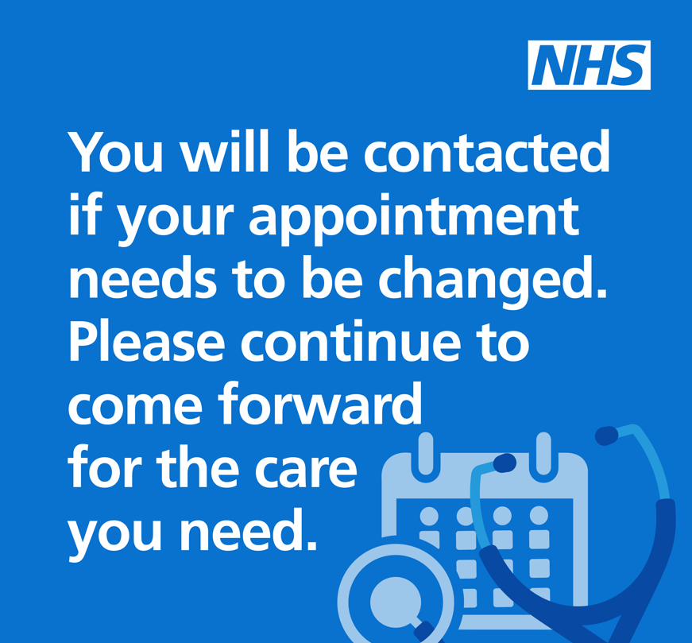
Industrial action taking place in England
Trade unions representing some NHS staff are in dispute with the Government over the 2022/23 pay award. A number of the unions have balloted their NHS members to take part in industrial action.
Information on NHS preparations for industrial action can be found here, which includes information for the public. The default approach should be that appointments and operations should continue unless there is a clear patient safety reason to reschedule. Healthcare providers should communicate that people should continue to attend appointments unless told otherwise.
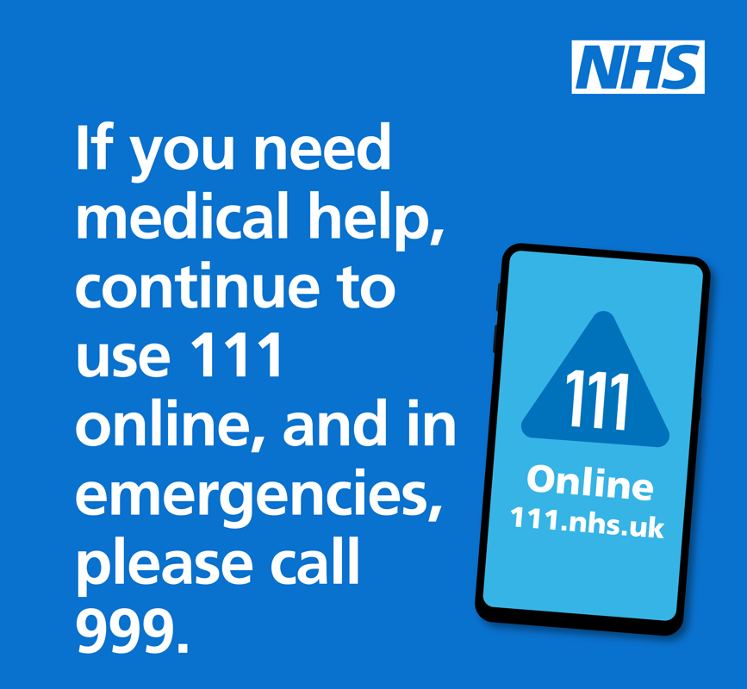
Where appointments and procedures are rescheduled, patient communications must be prioritised to ensure patients are made aware of any changes and are supported with re-booking in advance of strike action. Where there is a need for appointments to be rescheduled, any patient messaging should focus on what continues to be available.
We want to see a resolution as soon as possible to the strikes, but ultimately pay is a matter for the Government and the trade unions.

Reminder of NHS care and support for survivors of sexual assault and abuse
In support of Sexual Abuse and Sexual Violence Awareness Week (6-12 February), NHS England is raising awareness of sexual assault referral centres (SARCs) - specialist NHS services that offer specialist practical, medical and emotional support 24/7 to anyone who has been raped, sexually assaulted or abused.
SARCs are located across the country and are here for everyone, regardless of when an incident happened. They are staffed by health and wellbeing professionals, who can provide support to individuals and arrange counselling and therapy sessions following rape, sexual assault or abuse.
You can self-refer and, unless there is a safety issue, it’s up to you whether to involve the police or not. If you have been raped, sexually assaulted or abused and don't know where to turn, go to https://www.nhs.uk/SARCs to find your nearest service.
To support with raising awareness of SARCs, please see the campaign toolkit here. We would really appreciate your help with raising awareness of these important services.

Upcoming events

7-8 March 2023 | Veteran’s mental health conference | London
 | The King’s Centre for Military Health Research (KCMHR) has been running a mental health focused conference for many years which have been kindly supported by Forces in Mind Trust (FiMT).

Engagement opportunities
The below engagement opportunities may be of interest. Please note that whilst these may be of interest, they may not necessarily be associated with NHS England.

Veterans in the criminal justice system | We are holding three focus groups to inform the naming of the veterans in the criminal justice system service. If you would like to take part, please register here. | Register by 15 February

